**Data Analysis and Visualization Practical**

**Name: Kuldeep Saini**

**College Roll No.: 20201415**

**Exam Roll No.: 20020570017**

**Semester: 5th**

**Subject: Data Analysis and Visualization**

**Course: BSc. (Hons) Computer Science**

{'Boys': [72, 68, 70, 69, 74], 'Girls': [63, 65, 69, 62, 61]}

import pandas as pd

pd.DataFrame(DL).to_dict(orient="records")

[{'Boys': 72, 'Girls': 63},

{'Boys': 68, 'Girls': 65},

{'Boys': 70, 'Girls': 69},

{'Boys': 69, 'Girls': 62},

{'Boys': 74, 'Girls': 61}]

# Q2. a

import numpy as np x = np.array([[10, 30], [20, 60],[40,100]]) print("Mean of each row:") print(x.mean(axis=1)) print("Standard

Deviation:") print(np.std(x,axis=1)) print("Variance:")

print(np.var(x,axis=1) )

Mean of each row: [20. 40.

70.]

Standard Deviation: [10. 20.

30.] Variance:

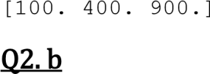

import numpy as np

B = np.array( [56, 48, 22, 41, 78, 91, 24, 46, 8, 33]) print("Original array:") print(B) i = np.argsort(B) print("Indices of the sorted elements of a given array:")

print(i)

Original array:

[56 48 22 41 78 91 24 46 8 33]

Indices of the sorted elements of a given array:

[8 2 6 9 3 7 1 0 4 5]

# Q2.c

import numpy as np

R = int(input("Enter the number of rows:"))

C = int(input("Enter the number of columns:")) matrix = []

print("Enter the entries rowwise:")

**for** i **in** range(R): *# A for loop for row entries* a =[]

**for** j **in** range(C): *# A for loop for column entries*

a.append(int(input()))

matrix.append(a)

**for** i **in** range(R): **for**

j **in** range(C): print(matrix[i][j], end = " ")

print()

print(np.shape(matrix))

print(type(matrix)) newarray = np.transpose(matrix) print(newarray)

Enter the number of rows:3

Enter the number of columns:4

Enter the entries rowwise:

1 2 3

4

5 6 6

5

4

3

2

1

1 2 3 4

5 6 6 5

4 3 2 1

(3, 4)

<class 'list'>

[[1 5 4]

[2 6 3] [3 6 2]

[4 5 1]]

import math as math arr =

[1,3,4,0,7,5,3,0,7,] **def** find (arr): **return** [i **for** i, x **in** enumerate(arr) **if** x != 0 **and not**  math.isnan(x)]

**def** find_zero(arr): **return** [i **for** i , x **in** enumerate(arr) **if** x ==0]

arr1 = find(arr) arr2 =find_zero(arr) print(arr1) print(arr2)

[0, 1, 2, 4, 5, 6, 8]

[3, 7]

# Q3

import pandas as pd import numpy as np df = pd.DataFrame(np.random.randint(0,100,size=(75,

4)), columns=list('ABCD')) df

A B C D

1. 85 67 26 95
2. 12 23 23 17
3. 11 18 18 72
4. 92 4 33 80 4 78 55 20 56 .. .. .. .. ..
5. 73 77 53 44
6. 18 56 66 43
7. 79 40 89 60
8. 51 30 85 69
9. 78 98 34 45

[75 rows x 4 columns] **def** num_null(df):

null_num = int(df.shape[0] * 0.1) null_index = np.random.choice(df.index, null_num, replace=False) df.loc[null_index] = np.nan **return** df

num_null(df)

A B C D

1. 85.0 67.0 26.0 95.0
2. 12.0 23.0 23.0 17.0
3. 11.0 18.0 18.0 72.0
4. 92.0 4.0 33.0 80.0 4 78.0 55.0 20.0 56.0 .. ... ... ... ...
5. 73.0 77.0 53.0 44.0
6. 18.0 56.0 66.0 43.0
7. NaN NaN NaN NaN
8. 51.0 30.0 85.0 69.0
9. 78.0 98.0 34.0 45.0

[75 rows x 4 columns]

Q3. a df.isnull().sum()

1. 7
2. 7
3. 7
4. 7

dtype: int64 df.isnull()

A B C D

1. False False False False
2. False False False False
3. False False False False
4. False False False False
5. False False False False

.. ... ... ... ...

1. False False False False
2. False False False False
3. True True True True
4. False False False False
5. False False False False

[75 rows x 4 columns] df['sum']=df.sum(axis=1) df.head()

A B C D sum

1. 85.0 67.0 26.0 95.0 273.0
2. 12.0 23.0 23.0 17.0 75.0
3. 11.0 18.0 18.0 72.0 119.0 3 92.0 4.0 33.0 80.0 209.0 4 78.0 55.0 20.0 56.0 209.0

df.sort_values('sum',ascending=False)

A B C D sum

18 77.0 97.0 64.0 47.0 285.0

39 75.0 46.0 72.0 92.0 285.0

44 79.0 93.0 85.0 24.0 281.0 0 85.0 67.0 26.0 95.0 273.0

33 94.0 54.0 48.0 69.0 265.0

25 66.0 97.0 9.0 92.0 264.0

22 32.0 56.0 97.0 79.0 264.0 5 20.0 85.0 72.0 78.0 255.0

26 83.0 34.0 74.0 62.0 253.0

49 44.0 43.0 63.0 99.0 249.0

30 96.0 33.0 66.0 53.0 248.0

70 73.0 77.0 53.0 44.0 247.0

61 24.0 41.0 93.0 86.0 244.0

7 67.0 52.0 26.0 99.0 244.0

50 36.0 22.0 94.0 89.0 241.0

23 69.0 20.0 82.0 67.0 238.0

73 51.0 30.0 85.0 69.0 235.0

12 27.0 73.0 62.0 70.0 232.0

52 59.0 99.0 39.0 32.0 229.0

27 7.0 90.0 46.0 76.0 219.0

6 53.0 79.0 44.0 37.0 213.0

34 64.0 32.0 18.0 96.0 210.0 3 92.0 4.0 33.0 80.0 209.0

4 78.0 55.0 20.0 56.0 209.0

14 91.0 4.0 97.0 14.0 206.0

21 48.0 70.0 12.0 75.0 205.0

9 52.0 40.0 86.0 26.0 204.0

19 3.0 87.0 35.0 75.0 200.0

38 82.0 35.0 82.0 1.0 200.0

54 98.0 35.0 33.0 27.0 193.0

24 60.0 28.0 27.0 76.0 191.0

71 18.0 56.0 66.0 43.0 183.0

36 15.0 63.0 48.0 53.0 179.0 8 93.0 7.0 54.0 25.0 179.0

67 45.0 71.0 13.0 48.0 177.0

32 72.0 30.0 15.0 55.0 172.0 45 4.0 62.0 21.0 85.0 172.0

48 35.0 31.0 82.0 22.0 170.0

41 40.0 44.0 48.0 38.0 170.0 10 1.0 19.0 64.0 86.0 170.0

68 21.0 51.0 63.0 34.0 169.0 16 58.0 58.0 24.0 20.0 160.0

17 71.0 4.0 6.0 74.0 155.0 20 6.0 14.0 94.0 40.0 154.0

53 49.0 31.0 23.0 38.0 141.0

69 26.0 55.0 18.0 40.0 139.0 11 87.0 11.0 38.0 1.0 137.0

64 10.0 17.0 76.0 31.0 134.0 28 29.0 79.0 5.0 7.0 120.0

2 11.0 18.0 18.0 72.0 119.0

55 65.0 24.0 9.0 20.0 118.0

29 12.0 93.0 7.0 2.0 114.0

13 56.0 20.0 31.0 7.0 114.0 60 0.0

27.0 67.0 5.0 99.0

15 NaN NaN NaN NaN 0.0

df.drop(18,inplace=True) df

A B C D sum

0 85.0 67.0 26.0 95.0 273.0

2 11.0 18.0 18.0 72.0 119.0 3

92.0 4.0 33.0 80.0 209.0 4 78.0 55.0 20.0 56.0 209.0

1. 20.0 85.0 72.0 78.0 255.0
2. 53.0 79.0 44.0 37.0 213.0
3. 67.0 52.0 26.0 99.0 244.0 8 93.0 7.0 54.0 25.0 179.0 9 52.0 40.0

86.0 26.0 204.0

1. 1.0 19.0 64.0 86.0 170.0
2. 87.0 11.0 38.0 1.0 137.0 12 27.0 73.0 62.0 70.0 232.0
3. 56.0 20.0 31.0 7.0 114.0
4. 91.0 4.0 97.0 14.0 206.0
5. NaN NaN NaN NaN 0.0
6. 58.0 58.0 24.0 20.0 160.0
7. 71.0 4.0 6.0 74.0 155.0
8. 3.0 87.0 35.0 75.0 200.0
9. 6.0 14.0 94.0 40.0 154.0
10. 48.0 70.0 12.0 75.0 205.0
11. 32.0 56.0 97.0 79.0 264.0
12. 69.0 20.0 82.0 67.0 238.0
13. 60.0 28.0 27.0 76.0 191.0
14. 66.0 97.0 9.0 92.0 264.0
15. 83.0 34.0 74.0 62.0 253.0
16. 7.0 90.0 46.0 76.0 219.0
17. 29.0 79.0 5.0 7.0 120.0
18. 12.0 93.0 7.0 2.0 114.0
19. 96.0 33.0 66.0 53.0 248.0

32 72.0 30.0 15.0 55.0 172.0 33 94.0 54.0 48.0 69.0 265.0

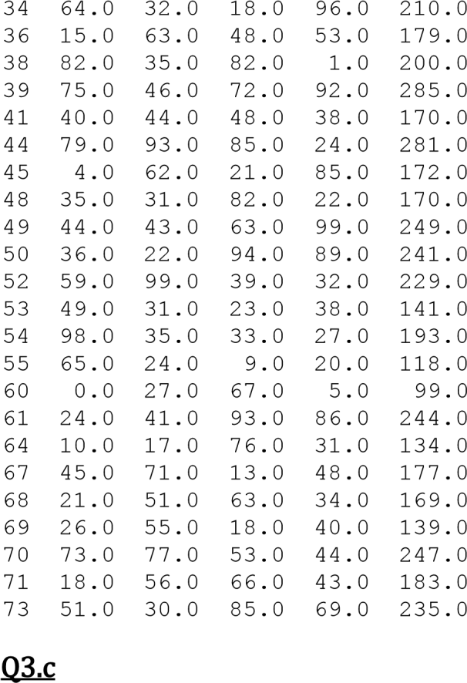

mod_df = df.dropna( axis=0,

thresh=5)

mod_df

A B C D sum

0 85.0 67.0 26.0 95.0 273.0

1. 11.0 18.0 18.0 72.0 119.0
2. 92.0 4.0 33.0 80.0 209.0
3. 78.0 55.0 20.0 56.0 209.0
4. 20.0 85.0 72.0 78.0 255.0 .. ... ... ... ... ...
5. 26.0 55.0 18.0 40.0 139.0
6. 73.0 77.0 53.0 44.0 247.0
7. 18.0 56.0 66.0 43.0 183.0
8. 51.0 30.0 85.0 69.0 235.0
9. 78.0 98.0 34.0 45.0 255.0

[67 rows x 5 columns]

# Q3. d

sort_col = df.sort_values(by= 'A',ascending=False) sort_col

A B C D sum

54 98.0 35.0 33.0 27.0 193.0

30 96.0 33.0 66.0 53.0 248.0

33 94.0 54.0 48.0 69.0 265.0

8 93.0 7.0 54.0 25.0 179.0

3 92.0 4.0 33.0 80.0 209.0

14 91.0 4.0 97.0 14.0 206.0

11 87.0 11.0 38.0 1.0 137.0

0 85.0 67.0 26.0 95.0 273.0

26 83.0 34.0 74.0 62.0 253.0

38 82.0 35.0 82.0 1.0 200.0

44 79.0 93.0 85.0 24.0 281.0 4 78.0 55.0 20.0 56.0 209.0

18 77.0 97.0 64.0 47.0 285.0

39 75.0 46.0 72.0 92.0 285.0

70 73.0 77.0 53.0 44.0 247.0

32 72.0 30.0 15.0 55.0 172.0 17 71.0 4.0 6.0 74.0 155.0

23 69.0 20.0 82.0 67.0 238.0

7 67.0 52.0 26.0 99.0 244.0

25 66.0 97.0 9.0 92.0 264.0

55 65.0 24.0 9.0 20.0 118.0

34 64.0 32.0 18.0 96.0 210.0

24 60.0 28.0 27.0 76.0 191.0

52 59.0 99.0 39.0 32.0 229.0

16 58.0 58.0 24.0 20.0 160.0

13 56.0 20.0 31.0 7.0 114.0

6 53.0 79.0 44.0 37.0 213.0

9 52.0 40.0 86.0 26.0 204.0

73 51.0 30.0 85.0 69.0 235.0

53 49.0 31.0 23.0 38.0 141.0

21 48.0 70.0 12.0 75.0 205.0

67 45.0 71.0 13.0 48.0 177.0

49 44.0 43.0 63.0 99.0 249.0

41 40.0 44.0 48.0 38.0 170.0

50 36.0 22.0 94.0 89.0 241.0

48 35.0 31.0 82.0 22.0 170.0

22 32.0 56.0 97.0 79.0 264.0 28 29.0 79.0 5.0 7.0 120.0

12 27.0 73.0 62.0 70.0 232.0

69 26.0 55.0 18.0 40.0 139.0

61 24.0 41.0 93.0 86.0 244.0

68 21.0 51.0 63.0 34.0 169.0 5 20.0 85.0 72.0 78.0 255.0

71 18.0 56.0 66.0 43.0 183.0

36 15.0 63.0 48.0 53.0 179.0

29 12.0 93.0 7.0 2.0 114.0

2 11.0 18.0 18.0 72.0 119.0

64 10.0 17.0 76.0 31.0 134.0

27 7.0 90.0 46.0 76.0 219.0

20 6.0 14.0 94.0 40.0 154.0

45 4.0 62.0 21.0 85.0 172.0 19 3.0 87.0 35.0 75.0 200.0

10 1.0 19.0 64.0 86.0 170.0 60 0.0

27.0 67.0 5.0 99.0

15 NaN NaN NaN NaN 0.0

# Q3. e

df.drop_duplicates(subset='A',keep='first',inplace=True) df

A B C D sum

0 85.0 67.0 26.0 95.0 273.0

1. 11.0 18.0 18.0 72.0 119.0
2. 92.0 4.0 33.0 80.0 209.0
3. 78.0 55.0 20.0 56.0 209.0
4. 20.0 85.0 72.0 78.0 255.0
5. 53.0 79.0 44.0 37.0 213.0
6. 67.0 52.0 26.0 99.0 244.0
7. 93.0 7.0 54.0 25.0 179.0
8. 52.0 40.0 86.0 26.0 204.0
9. 1.0 19.0 64.0 86.0 170.0
10. 87.0 11.0 38.0 1.0 137.0
11. 27.0 73.0 62.0 70.0 232.0
12. 56.0 20.0 31.0 7.0 114.0
13. 91.0 4.0 97.0 14.0 206.0 15 NaN NaN NaN NaN 0.0
14. 58.0 58.0 24.0 20.0 160.0
15. 71.0 4.0 6.0 74.0 155.0
16. 77.0 97.0 64.0 47.0 285.0
17. 3.0 87.0 35.0 75.0 200.0
18. 6.0 14.0 94.0 40.0 154.0
19. 48.0 70.0 12.0 75.0 205.0
20. 32.0 56.0 97.0 79.0 264.0
21. 69.0 20.0 82.0 67.0 238.0
22. 60.0 28.0 27.0 76.0 191.0
23. 66.0 97.0 9.0 92.0 264.0
24. 83.0 34.0 74.0 62.0 253.0
25. 7.0 90.0 46.0 76.0 219.0
26. 29.0 79.0 5.0 7.0 120.0
27. 12.0 93.0 7.0 2.0 114.0
28. 96.0 33.0 66.0 53.0 248.0
29. 72.0 30.0 15.0 55.0 172.0
30. 94.0 54.0 48.0 69.0 265.0
31. 64.0 32.0 18.0 96.0 210.0

36 15.0 63.0 48.0 53.0 179.0 38 82.0 35.0 82.0 1.0 200.0

39 75.0 46.0 72.0 92.0 285.0

41 40.0 44.0 48.0 38.0 170.0

1. 79.0 93.0 85.0 24.0 281.0
2. 4.0 62.0 21.0 85.0 172.0

48 35.0 31.0 82.0 22.0 170.0

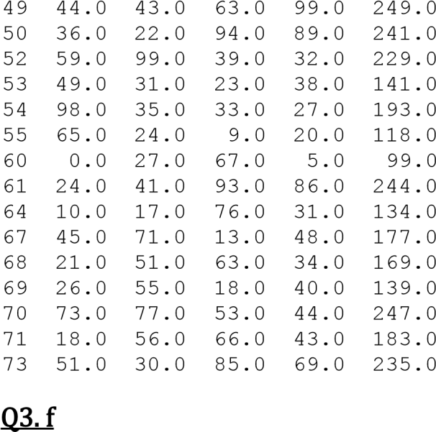

column_1 = df["A"] column_2 = df["B"] correlation = column_1.corr(column_2) correlation

-0.1914983464702535 print(df.B.cov(df.C))

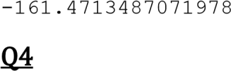

xls1=pd.ExcelFile('/content/Attendance1.xlsx'

) xls1.sheet_names f1=pd.read_excel(xls1,xls1.sheet_names[0]) f1 xls2=pd.ExcelFile('/content/Attendance2.xlsx'

) xls2.sheet_names f2=pd.read_excel(xls2,xls2.sheet_names[0]) f2 Q4. a

j=pd.merge(f1,f2,on=['Name']) j['Name'] Q4. b k=pd.merge(f1,f2,how='outer',on=['Name'])



k['Name']

# Q4. c

frames=[f1,f2] result=pd.concat(frames,

keys=['f1', 'f2']) result Q4. d f_new=pd.merge(f1,f2) df2=f_new.set_index(keys=[f_new.columns[0],f_new.columns[2]]

) df2 df2.describe()

# Q5

import numpy as np import pandas as pd import seaborn as sns sns.set_palette('husl') import matplotlib.pyplot as plt

%matplotlib inline data = pd.read_csv('Iris.csv') data.head()

Id SepalLengthCm SepalWidthCm PetalLengthCm PetalWidthCm

Species

1. 1 5.1 3.5 1.4 0.2 Iris- setosa
2. 2 4.9 3.0 1.4 0.2 Iris- setosa
3. 3 4.7 3.2 1.3 0.2 Iris- setosa
4. 4 4.6 3.1 1.5 0.2 Iris- setosa
5. 5 5.0 3.6 1.4 0.2 Iris- setosa

data.plot(kind='scatter', x='PetalWidthCm',y='SepalWidthCm') plt.show

*c* argument looks like a single numeric RGB or RGBA sequence, which should be avoided as value-mapping will have precedence in case its length matches with *x* & *y*. Please use the *color* keyword- argument or provide a 2-D array with a single row if you intend to specify the same RGB or RGBA value for all points.

<function matplotlib.pyplot.show>

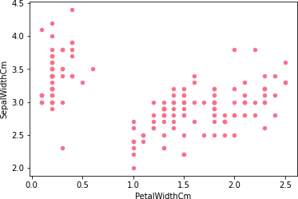

sns.barplot(x='Species',y='SepalLengthCm',data=data)

<matplotlib.axes._subplots.AxesSubplot at 0x7ff64c763310>

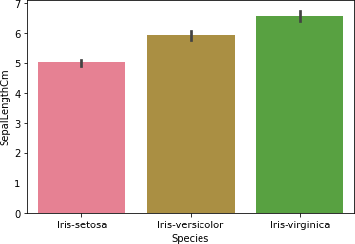

sns.barplot(x='Species',y='SepalWidthCm',data=data)

<matplotlib.axes._subplots.AxesSubplot at 0x7ff64c263450>

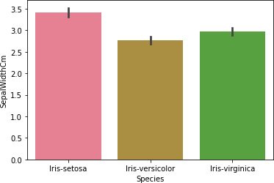

sns.barplot(x='Species',y='PetalLengthCm',data=data)

<matplotlib.axes._subplots.AxesSubplot at 0x7ff64c1ddc10>

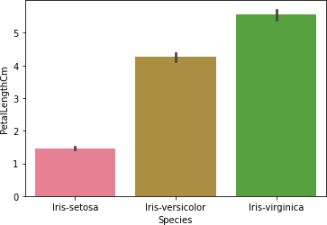

sns.barplot(x='Species',y='PetalWidthCm',data=data)

<matplotlib.axes._subplots.AxesSubplot at 0x7ff64c14df50>

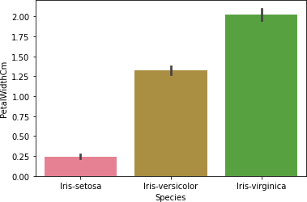

data.PetalLengthCm.plot.density(color='green') plt.title('Density Plot for Petal Length') plt.show()

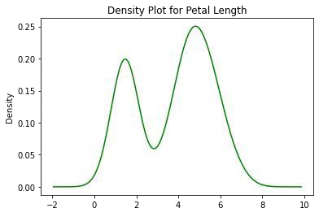

sns.pairplot(data)

<seaborn.axisgrid.PairGrid at 0x7ff64c6c3990>

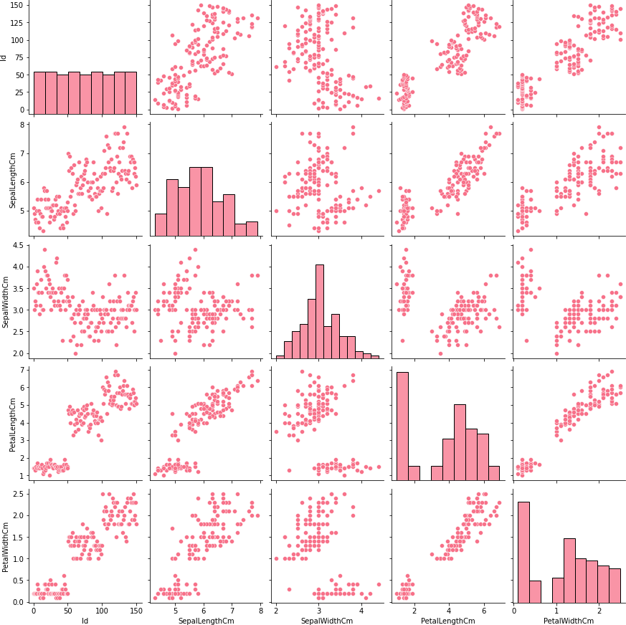

 data2=

pd.read_csv('https://raw.githubusercontent.com/codebasics/py/master/

pandas/14_ts_datetimeindex/aapl.csv') data2.head(10)

Date Open High Low Close Volume

1. 7-Jul-17 142.90 144.75 142.90 144.18 19201712
2. 6-Jul-17 143.02 143.50 142.41 142.73 24128782
3. 5-Jul-17 143.69 144.79 142.72 144.09 21569557
4. 3-Jul-17 144.88 145.30 143.10 143.50 14277848
5. 30-Jun-17 144.45 144.96 143.78 144.02 23024107
6. 29-Jun-17 144.71 145.13 142.28 143.68 31499368
7. 28-Jun-17 144.49 146.11 143.16 145.83 22082432
8. 27-Jun-17 145.01 146.16 143.62 143.73 24761891
9. 26-Jun-17 147.17 148.28 145.38 145.82 25692361 9 23-Jun-17 145.13

147.16 145.11 146.28 35439389 data2.groupby('Open')['Volume'].mean()

Open

|  |  |
| --- | --- |
| 96.75  96.82  97.17  97.39  97.41  155.02  155.19  155.25  155.94  156.01 | 23794945.0  56239822.0  24167463.0  38918997.0  25892171.0  ...  21069647.0  64882657.0  21250798.0  20048478.0  26009719.0 |

Name: Volume, Length: 246, dtype: float64 data2.groupby('Open', as_index=False)['Volume'].mean()

Open Volume

1. 96.75 23794945.0
2. 96.82 56239822.0
3. 97.17 24167463.0
4. 97.39 38918997.0
5. 97.41 25892171.0

.. ... ...

1. 155.02 21069647.0
2. 155.19 64882657.0
3. 155.25 21250798.0
4. 155.94 20048478.0
5. 156.01 26009719.0

[246 rows x 2 columns] data2['Date'] = pd.to_datetime(data2['Date']) data2.head(10)

Date Open High Low Close Volume

1. 2017-07-07 142.90 144.75 142.90 144.18 19201712
2. 2017-07-06 143.02 143.50 142.41 142.73 24128782
3. 2017-07-05 143.69 144.79 142.72 144.09 21569557
4. 2017-07-03 144.88 145.30 143.10 143.50 14277848
5. 2017-06-30 144.45 144.96 143.78 144.02 23024107
6. 2017-06-29 144.71 145.13 142.28 143.68 31499368
7. 2017-06-28 144.49 146.11 143.16 145.83 22082432
8. 2017-06-27 145.01 146.16 143.62 143.73 24761891
9. 2017-06-26 147.17 148.28 145.38 145.82 25692361
10. 2017-06-23 145.13 147.16 145.11 146.28 35439389 df_agg = data2.groupby(['High','Low']).agg({'Volume':sum}) result = df_agg['Volume'].groupby(level=0, group_keys=False) print(result.nlargest())

|  |  |  |
| --- | --- | --- |
| High Low |  | |
| 97.65 96.73 | 23794945 | |
| 97.67 96.84 | 25892171 | |
| 97.70 97.12 | 24167463 | |
| 97.97 96.42 | 56239822 | |
| 98.84 96.92 | 40382921 | |
|  | | ... |
| 155.81 153.78 | | 26624926 |
| 155.98 154.48 | | 21069647 |
| 156.06 154.72 | | 20048478 |
| 156.42 154.67 | | 32527017 |
| 156.65 155.05 | | 26009719 |

Name: Volume, Length: 251, dtype: int64

groups = data2.groupby(['Close', pd.cut(data2.Open,

3)]) result = groups.size().unstack() print(result)

Open (96.691, 116.503] (116.503, 136.257] (136.257, 156.01]

Close

96.67 1 0 0

96.87 1 0 0

96.98 1 0 0

97.34 1 0 0

97.42 1 0 0 ... ... ... ...

155.37 0 0 1

155.45 0 0 1

155.47 0 0 1

155.70 0 0 1

156.10 0 0 1

[239 rows x 3 columns]

# Q7

df3 = pd.DataFrame({

'Name':['Mudit Chauhan','Seema Chopra','rani gupta','aditya narayan','sanjeev sahani','prakash kumar','Ritu Agarwal','Akshay

Goel','Meeta Kulkarni','Preeti Ahuja','Sunil Das Gupta','Sonali Sapre','Rashmi Talwar','Ashish Dubey','Kiran Sharma','Sameer Bansal'],

'Birth_Month':

['December','January','March','October','February','December','Septemb er','August','July','November','April','January','May','June','Februar y','October'],

'Gender':

['M','F','F','M','M','M','F','M','F','F','M','F','F','M','F','M'], 'Pass_division':[3,2,1,1,2,3,1,1,2,2,3,1,3,2,2,1]})

df3 Name Birth_Month Gender Pass_division

1. Mudit Chauhan December M 3
2. Seema Chopra January F 2
3. rani gupta March F 1
4. aditya narayan October M 1
5. sanjeev sahani February M 2
6. prakash kumar December M 3
7. Ritu Agarwal September F 1
8. Akshay Goel August M 1
9. Meeta Kulkarni July F 2
10. Preeti Ahuja November F 2
11. Sunil Das Gupta April M 3
12. Sonali Sapre January F 1
13. Rashmi Talwar May F 3
14. Ashish Dubey June M 2
15. Kiran Sharma February F 2
16. Sameer Bansal October M 1

pd.get_dummies(df3.Gender) F M 0 0 1

1. 1 0
2. 1 0
3. 0 1
4. 0 1
5. 0 1
6. 1 0
7. 0 1
8. 1 0
9. 1 0
10. 0 1
11. 1 0
12. 1 0
13. 0 1 14 1 0 15 0 1

pd.get_dummies(df3.Gender, drop_first=True)

M 0 1

1. 0
2. 0
3. 1
4. 1
5. 1
6. 0
7. 1
8. 0
9. 0
10. 1
11. 0
12. 0
13. 1
14. 0 15 1

gender_dummies = pd.get_dummies(df3.Gender, prefix='Gender') gender_dummies

Gender_F Gender_M

1. 0 1
2. 1 0
3. 1 0
4. 0 1
5. 0 1
6. 0 1
7. 1 0
8. 0 1
9. 1 0
10. 1 0
11. 0 1
12. 1 0
13. 1 0
14. 0 1
15. 1 0
16. 0 1

df3 = pd.concat([df3, gender_dummies], axis=1) df3.head()

Name Birth_Month Gender Pass_division Gender_F

Gender_M

* 1. Mudit Chauhan December M 3 0

1

* 1. Seema Chopra January F 2 1

0

* 1. rani gupta March F 1 1

0

* 1. aditya narayan October M 1 0

1

* 1. sanjeev sahani February M 2 0

1

pass_dummies = pd.get_dummies(df3.Pass_division, prefix='pass')

pass_dummies.head() pass_1 pass_2 pass_3 0

* 1. 0 1
  2. 0 1 0
  3. 1 0 0
  4. 1 0 0
  5. 0 1 0

df3 = pd.concat([df3, pass_dummies], axis=1)

df3.head()

Name Birth_Month Gender ... pass_1 pass_2 pass_3

* 1. Mudit Chauhan December M ... 0 0 1
  2. Seema Chopra January F ... 0 1 0
  3. rani gupta March F ... 1 0 0
  4. aditya narayan October M ... 1 0 0 4 sanjeev sahani February M ... 0 1 0

* 1. rows x 9 columns]

df3

Name Birth_Month Gender ... pass_1 pass_2 pass_3

* 1. Mudit Chauhan December M ... 0 0 1
  2. Seema Chopra January F ... 0 1 0
  3. rani gupta March F ... 1 0 0
  4. aditya narayan October M ... 1 0 0
  5. sanjeev sahani February M ... 0 1 0
  6. prakash kumar December M ... 0 0 1
  7. Ritu Agarwal September F ... 1 0 0
  8. Akshay Goel August M ... 1 0 0
  9. Meeta Kulkarni July F ... 0 1 0
  10. Preeti Ahuja November F ... 0 1 0
  11. Sunil Das Gupta April M ... 0 0 1
  12. Sonali Sapre January F ... 1 0 0
  13. Rashmi Talwar May F ... 0 0 1
  14. Ashish Dubey June M ... 0 1 0
  15. Kiran Sharma February F ... 0 1 0
  16. Sameer Bansal October M ... 1 0 0

[16 rows x 9 columns] df3.sort_values(by='Birth_Month')

Name Birth_Month Gender ... pass_1 pass_2 pass_3

10 Sunil Das Gupta April M ... 0 0 1

7 Akshay Goel August M ... 1 0 0

0 Mudit Chauhan December M ... 0 0 1

5 prakash kumar December M ... 0 0 1

4 sanjeev sahani February M ... 0 1 0

14 Kiran Sharma February F ... 0 1 0

1 Seema Chopra January F ... 0 1 0

11 Sonali Sapre January F ... 1 0 0

8 Meeta Kulkarni July F ... 0 1 0

13 Ashish Dubey June M ... 0 1 0

2 rani gupta March F ... 1 0 0

12 Rashmi Talwar May F ... 0 0 1

9 Preeti Ahuja November F ... 0 1 0

3 aditya narayan October M ... 1 0 0

15 Sameer Bansal October M ... 1 0 0

* 1. Ritu Agarwal September F ... 1 0 0

[16 rows x 9 columns]

sort_order =

['January','February','March','April','May','June','July','August','S e ptember','October','November','December'] df3.index = pd.CategoricalIndex(df3['Birth_Month'], categories=sort_order,ordered=True) df3 = df3.sort_index().reset_index(drop=True) df3

Name Birth_Month Gender ... pass_1 pass_2 pass_3

* 1. Seema Chopra January F ... 0 1 0
  2. Sonali Sapre January F ... 1 0 0
  3. sanjeev sahani February M ... 0 1 0
  4. Kiran Sharma February F ... 0 1 0
  5. rani gupta March F ... 1 0 0
  6. Sunil Das Gupta April M ... 0 0 1
  7. Rashmi Talwar May F ... 0 0 1
  8. Ashish Dubey June M ... 0 1 0
  9. Meeta Kulkarni July F ... 0 1 0
  10. Akshay Goel August M ... 1 0 0
  11. Ritu Agarwal September F ... 1 0 0
  12. aditya narayan October M ... 1 0 0
  13. Sameer Bansal October M ... 1 0 0
  14. Preeti Ahuja November F ... 0 1 0
  15. Mudit Chauhan December M ... 0 0 1
  16. prakash kumar December M ... 0 0 1

[16 rows x 9 columns]

= pd.DataFrame({

'Name':

['Shah','Vats','Vats','Kumar','Vats','Kumar','Shah','Shah','Kumar','Sh ah'],

'Gender':

['Male','Male' ,'Female','Female','Female','Male','Male','Female','Fem ale','Male'],

'Monthly_Income (Rs)':

[114000,65000,43150,69500,155000,103000,55000,112400,81030,71900]})

df4

Name Gender Monthly_Income (Rs)

1. Shah Male 114000
2. Vats Male 65000
3. Vats Female 43150
4. Kumar Female 69500
5. Vats Female 155000
6. Kumar Male 103000
7. Shah Male 55000
8. Shah Female 112400
9. Kumar Female 81030
10. Shah Male 71900

sumOfIncome = df4.groupby(by=['Name'],

as_index=False)['Monthly_Income (Rs)'].sum()

print (sumOfIncome)

Name Monthly_Income (Rs)

1. Kumar 253530
2. Shah 353300 2 Vats 263150

grouped = df4.groupby(['Name'], sort=False)['Monthly_Income

(Rs)'].max() print(grouped)

Name

Shah 114000

Vats 155000

Kumar 103000 Name: Monthly_Income (Rs), dtype: int64 res = df4[df4['Monthly_Income (Rs)'] > 60000] res

Name Gender Monthly_Income (Rs)

1. Shah Male 114000
2. Vats Male 65000
3. Kumar Female 69500
4. Vats Female 155000
5. Kumar Male 103000
6. Shah Female 112400
7. Kumar Female 81030 9 Shah Male 71900

res4 = df4[(df4['Name'] == 'Shah') &

(df4['Gender'] == 'Female')] res4.mean()

Monthly_Income (Rs) 112400.0 dtype:

float64